Cervical smear screening
Cervical screening (a smear test) checks the health of your cervix. The cervix is the opening of your womb accessed through your vagina. It is not a test for cancer, it is a test to help prevent cancer and identify early warning cells.
When will you be invited for cervical screening?
You will receive a letter in the post inviting you to make an appointment.
Age When you are invited
Under 25 up to 6 months Before you turn 25
25 to 49 Every 3 years
50 to 64 Every 5 years
65 or older Only if 1 of your last
3 tests was abnormal
What happens during the appointment
During the screening appointment, a small sample of cells will be taken from your cervix.
The sample is checked for certain types of human papillomavirus (HPV) that can cause changes to the cells of your cervix.
If these types of HPV are not found, you do not need any further tests.
If these types of HPV are found, the sample is then checked for any changes in the cells of your cervix. These can then be treated before they get a chance to turn into cervical cancer.
It is best to book an appointment for a time when you are not having a period and / or have finished treatment for unusual vaginal discharge or a pelvic infection.
For a video on how cervical screening is carried out and for more information please follow the link:
https://www.nhs.uk/conditions/cervical-screening/what-happens-at-your-appointment/
Results
You will get your results by letter, usually in 2 weeks. It will explain what happens next. If you have waited longer than expected, call your GP surgery to see if they have any updates.
Further help and support with cervical screening
• Support for people with a learning disability: GOV.UK has an easy read guide to cervical screening. https://www.gov.uk/government/publications/cervical-screening-easy-read-guide
• Support for LGBT people: the LGBT Foundation has information and support about cervical screening for LGBT people. https://lgbt.foundation/screening
• For further information on cervical screening please follow the link to the NHS website: https://www.nhs.uk/conditions/cervical-screening/

Bowel Cancer Screening
A bowel cancer screening test is a stool test sent to your home that checks if you could have bowel cancer. It is available to everyone aged 60 and over.
Everyone aged 60 to 74 who is registered with a GP and lives in England is automatically sent a bowel cancer screening kit every 2 years.
If you are 75 or over, you can ask for a kit every 2 years by phoning the free bowel cancer screening helpline on 0800 707 60 60.

How to use the home test kit
The screening kit used in England is the faecal immunochemical test kit – known as the FIT kit.
You collect a small sample of poo on a small plastic stick and put it into the sample bottle and post it to a lab for testing.
There are instructions that come with the kit. You can also find bowel cancer screening kit instructions on GOV.UK.
Results
Your result should be posted to you within 2 weeks of sending off your kit.
If the test finds anything unusual, you might be asked to have further tests to confirm or rule out cancer.
For more information on the results please follow the link:
https://www.nhs.uk/conditions/bowel-cancer-screening/
Further help and support with bowel cancer screening
Call the free bowel cancer screening helpline on 0800 707 60 60 if:
- you have not had your result after 2 weeks from when you sent off your kit
- you want to know more about screening
- you do not want to be invited for bowel cancer screening
The Bowel Cancer Screening Programme has information in other formats, including:
- GOV.UK: bowel cancer screening guide in English and other languages
- GOV.UK: bowel cancer screening easy read guide
If you are concerned about bowel cancer please book a GP appointment.

Breast cancer screening
Breast screening aims to find breast cancer early.
As the likelihood of getting breast cancer increases with age, all women aged from 50 to their 71st birthday who are registered with a GP are automatically invited for breast cancer screening every 3 years through a letter.
You may be eligible for breast screening before the age of 50 if you have a very high risk of developing breast cancer.
If you are 71 or over, you will stop receiving screening invitations. But you can still ask to have breast screening – please visit the NHS breast cancer screening website to find the nearest breast screening units in your area.
If you have not received a letter for an appointment for your screening, please contact your GP.
In the meantime, if you are worried about breast cancer or have symptoms such as a lump or an area of thickened tissue in a breast, notice that your breasts look or feel different from what is normal for you do not wait; arrange an appointment to see a GP.
What happens during breast screening?
Breast screening involves having an X-ray (mammogram) at a special clinic or mobile breast screening unit. This is done by a female health practitioner.
Your breasts will be X-rayed 1 at a time.
The breast is placed on the X-ray machine and gently but firmly compressed with a clear plate.
Two X-rays are taken of each breast at different angles.
Please view the video on the following link for more information about ‘what happens during breast screening’:
https://www.nhs.uk/conditions/breast-cancer-screening/
Results
The results of the mammogram will be sent to you and your GP within 2 weeks after your appointment.
After screening you may be called back for further assessment or due to the first mammogram being unclear.
For more information on breast cancer screening please visit:
- https://www.nhs.uk/conditions/breast-cancer-screening/results/
- https://www.nhs.uk/conditions/breast-cancer-screening/
- https://www.gov.uk/government/publications/breast-screening-helping-women-decide

Spotting Cancer Early
This page covers key signs and symptoms of cancer, including those which can be early signs. Not every person with cancer has symptoms. But spotting cancer early saves lives, so seek help from your doctor if you notice anything that is not normal for you.
General Cancer symptoms:
- Unexplained pain or ache
- Heavy night sweats – this may be caused by infections, menopause or it can be a side effect of certain medications.
- Unexplained weight loss
- Unusual lump or swelling anywhere
- Fatigue – there are a lot of reasons you may feel more tired than usual, but if you are feeling tired for no clear reason it could be a sign that something is wrong – speak to your doctor.
- Skin changes – new mole or changes to a mole, sore that will not heal.
- Difficulty swallowing
- Unusual heart burn or indigestion – it is normal to feel slight discomfort or pain sometimes after eating a large, fatty or spicy meal. But if it is particularly painful, then you should see your doctor.
- Appetite loss – can happen for many different reasons, speak to your doctor if you have noticed that you are not as hungry as usual and it is not getting any better.
- Croaky voice or hoarseness – a croaky voice that has not gone away on its own should be checked out.
- Breathlessness – it is not unusual to feel out of breath every now and then but, if you notice that you are feeling more than usual or for a lot of the time tell your doctor.
- Persistent cough
- Changes in your poo or pee
- Unexplained bleeding or blood – includes blood in your poo, pee and vomiting or coughing.
- Mouth ulcer or patch that will not heal.
- Unusual breast changes
- Persistent bloating – it is quite common to experience bloated or swollen tummy that comes and goes but, if symptoms occur most days speak to your doctor.
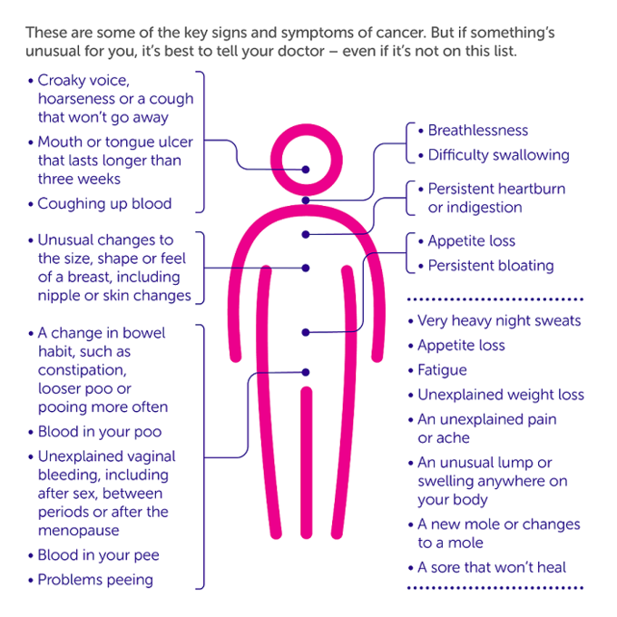

For more information please visit:
https://www.cancerresearchuk.org/about-cancer/cancer-symptoms

